SIXT CHINA DRIVERS LICENSE TRANSLATION
This document is a translation of a copy of the Chinese mainland driver’s license set forth below. It is not valid as an original license. You must carry your original Chinese mainland driver’s license with this form.
This document may be of assistance in translating your license for law enforcement officials as well as for rental of a vehicle from SIXT. However, this is not a legal document or a legal form of personal identification. This form shall not be used for any other purpose. If you have any questions renting a SIXT vehicle, please contact SIXT China at +86 400-869-2616 and ask for assistance. The call will be assisted by a Chinese and English speaking representative.
本文件仅用于SIXT中国客户的大陆驾驶执照翻译件，不能作为驾驶证原件使用，请将本翻译件与您的合法有效中国大陆驾驶执照原件一同使用。本文件可被用于您在租赁SIXT车辆时协助门店工作人员及相关执法机构了解您的驾照信息，不能用于任何其他用途。请注意本文件不是法定文件或者个人身份证明的法定文本。如您在租赁SIXT车辆时有任何问题请拨打+86 400-869-2616请求帮助，我们的客户中心将为您提供热忱的服务！
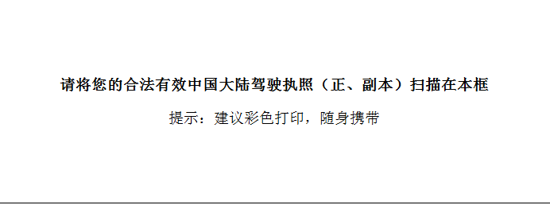
Name | 用英文填写您的姓名和护照一致
Date of Birth | 填写您驾驶证上的出生日期
Home Address | 用英文填写您驾驶证上的住址
Legal class to drive | C1或其他类型
Driver’s license first issue date | 驾驶证首次发放日期
Driver’s license expiration | 驾驶证有效日期
Driver’s license Number | 您的驾驶证号
Date of Translation Issue: | 翻译日期
* This form shall be valid for up to 1 year from the date of Translation Issue as long as the Chinese Mainland Driver’s License has not expired.
本翻译件在发出后的，并且在您的驾驶执照未过期之前的1年内有效。

I declare, under penalty of perjury, that the information that I have provided on this form is true and accurate.
我承诺以上提供的信息真实有效。

Signature（签名）___________________________

